Evacuation Simulation for an Office Building

By Kareem Johnson and Dwayne Farmer

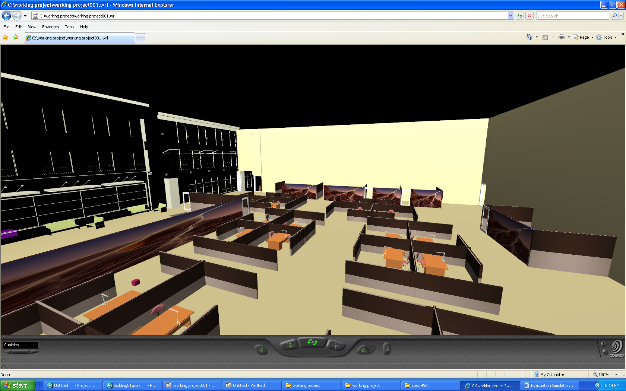

* Materials Used
  + Model of the building
  + People
  + Office Desks
  + Sinks
  + Toilets
  + Waiting Chairs
  + Doors

All materials listed above where copied from the same website which is

http://www.turbosquid.com

* + Textures Used in the model were gotten from Google Images.
* Software and Hardware used
  + Vrml
  + 3ds max
  + Cosmo Player
  + Internet Explorer
  + Computers in Vrml Lab
* Goals and Objective
  + We are going to show an evacuation simulation of an office building with add functionalities.
* Modeling
  + This application can be used to help people navigate through their office buildings. It shows them a 3 d image of their building and the closest exit to them.
  + Texture was used to add colors and design to the walls and floor of the model. It was also used to add a realistic look to the tables in the model
  + Several Animation was used in this model
    - The first one is animation of two cameras. One camera on the outside of the building and one on the inside of the building will provide motion that shows around the building.
  + Behaviors and Functionality was also added
    - Touch sensor are added to start the movement of the cameras. By clicking the box in the scene, the camera is start moving around the building.
    - Time sensor are added to the cameras and the door
    - Proximity sensor is added the door so the door will only open someone comes near it.
    - Interpolators are also added to show the motion of the people, doors and camera.
* Problems Encountered
  + Vrml was time consuming. Adding the functionalities took up most of the time and that does not mean they will work.
  + When trees and grass was added to our first model. We lost all our viewpoints so we had to restart from the beginning.
  + Not all objects are free from internet so we had to search for the free ones.
  + The front walls on the model are somewhat invisibly so that the background can be seen through the wall. We tried to change it but it did not work.
* Final Shortcomings
  + Proximity sensor are not working to the doors so will have to change them to touch sensors
  + Trees were not add because did not want to risk losing viewpoints and starting over again.
  + We wanted to add more than one routes for the evacuation but to due to time wasted on Vrml, only one evacuation will be shown.

